LinkedIn Profile

Student Name: Kartik Velede

Student Id: 8672807

Course Instructor: Kevin Swayze

Assignment Posted Date: 11th July 2020

Assignment Submission Date: 24th July 2020

**Step 1:** Below is the link to My Profile

<https://www.linkedin.com/in/kartik-velede-2814b7164/>

**Step 2:** My Profile Photo

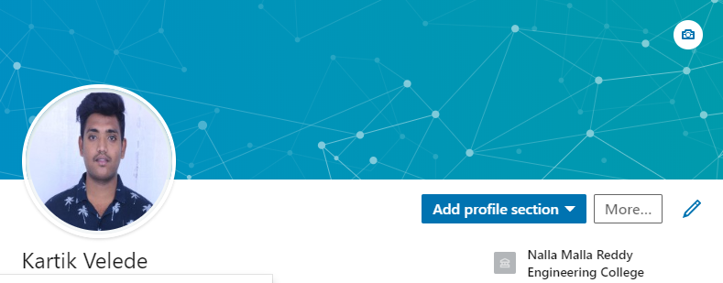

**Step 3:** Go to My Profile to create the headline.

“Student at Conestoga College” is my headline.

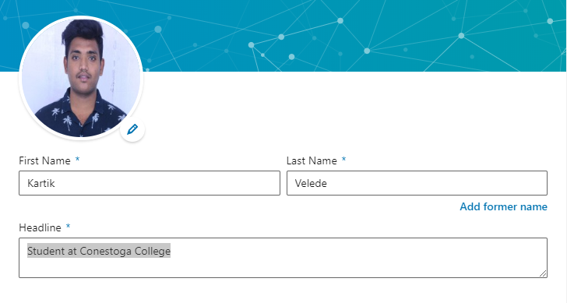

**Step 4:** Professional Summary

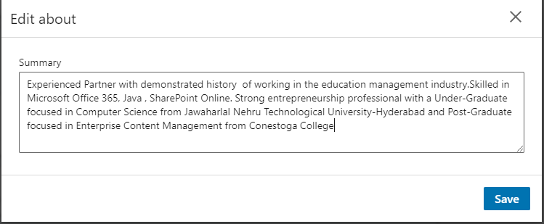

**Step 5:** My Experience

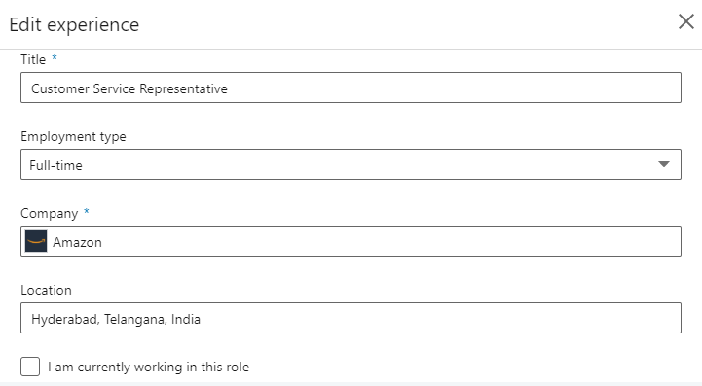

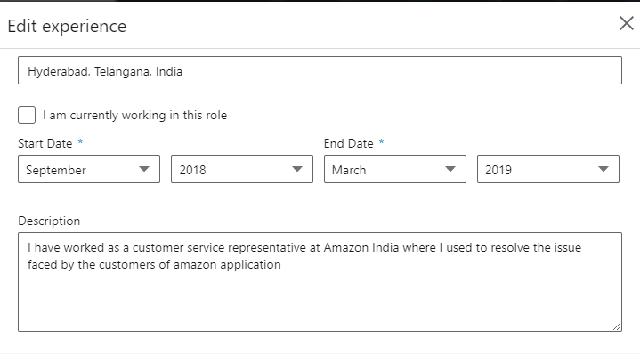

**Step 6:** My Education

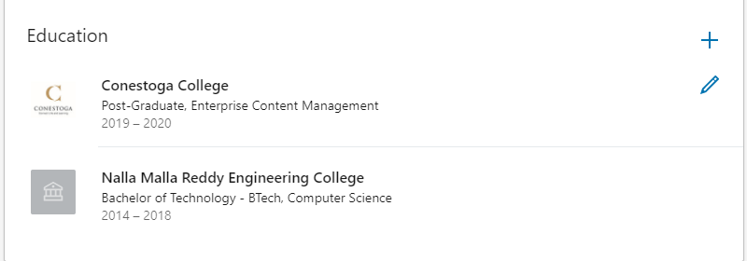

**Step 7:** My Skills

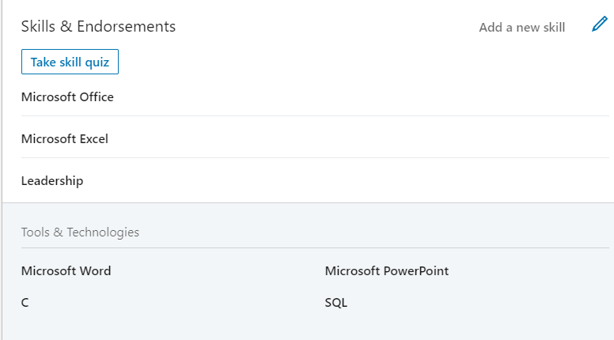

**Step 8:** Current Location

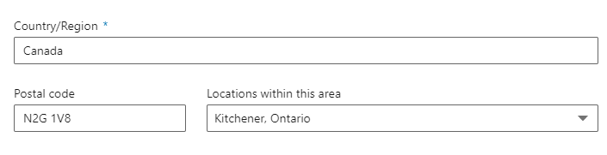

**Step 9:** Connected to Microsoft Office 365 group.

